AI Patient Triage System for Rural Healthcare Clinics
Azure AI + App Service Solution Architecture Mapping (POC → MVP Design)

0. Problem Context – Rural Healthcare Challenge
Rural clinics often lack 24/7 medical staff, forcing patients to make uninformed decisions about whether symptoms require urgent care. This leads to emergency room overcrowding, delayed treatment, and poor utilization of limited medical resources.
The goal of this solution is to design a repeatable AI-driven triage system that can be rapidly deployed across clinics using Azure AI services, enabling patients to receive immediate triage guidance while reducing the burden on medical staff.

1. Patient Symptom Input – Application Hosting Requirement

Requirement
Patients in rural clinics need a simple web interface to enter symptoms and receive triage guidance. This requires a secure, scalable, and managed web hosting environment that can expose an HTTPS endpoint without complex infrastructure setup.

Selected Service: Azure App Service (Web App)
Azure App Service is a fully managed platform for hosting web applications. It provides built-in HTTPS, autoscaling, deployment slots, and runtime support for Python/Flask applications, making it ideal for rapid POC to MVP transitions.

Why Azure App Service over Azure Virtual Machines?
Azure App Service | Azure VM
Fully managed PaaS | Requires OS management
Built-in HTTPS and scaling | Manual configuration needed
Faster deployment for MVP | Higher operational overhead
Cost-efficient for web apps | Overkill for simple web tier

Azure App Service allows focusing on application logic rather than infrastructure management, which aligns with rapid healthcare solution deployment.
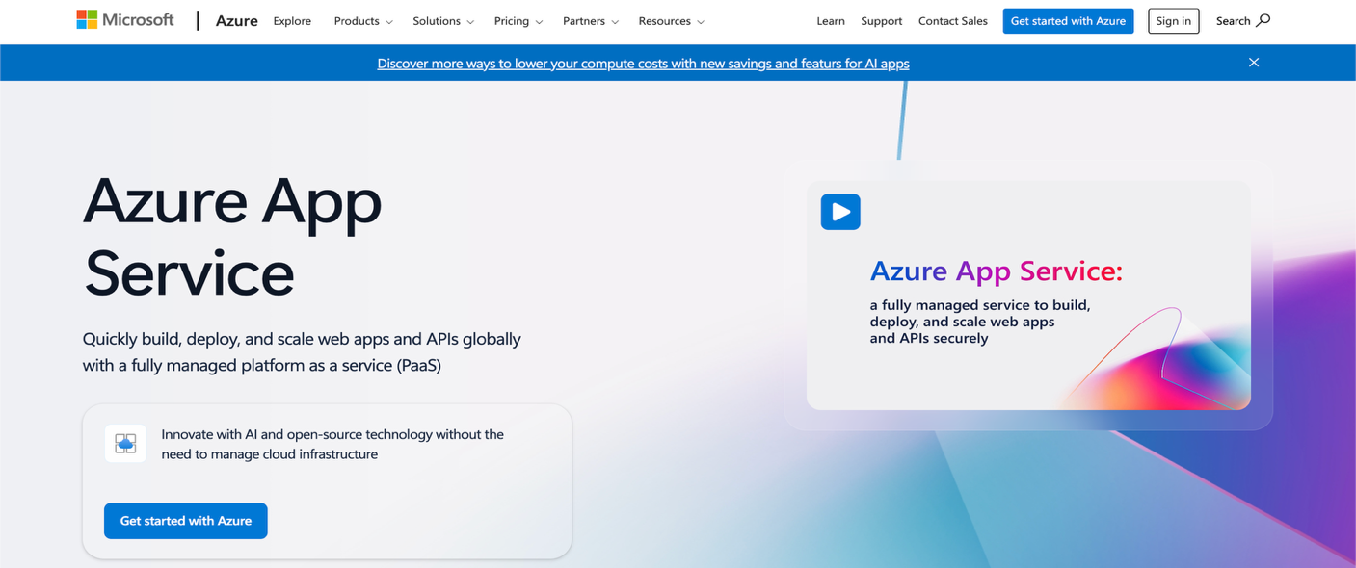

2. Symptom Reasoning – AI Processing Requirement

Requirement
The system must interpret patient symptoms and classify them into triage categories:
- Urgent care
- Non-urgent visit
- Self-care

Selected Service: Azure OpenAI Service (GPT-4 / GPT-4o)
Azure OpenAI provides enterprise-grade access to advanced language models capable of contextual reasoning and explanation generation. This enables an agentic triage workflow where the AI not only classifies severity but explains the reasoning.

Why Azure OpenAI over Copilot Studio or Azure ML?
Azure OpenAI | Copilot Studio | Azure ML
Direct model control | Requires enterprise setup | Requires model training
Prompt-based reasoning | Workflow-oriented bots | Heavy for POC
Fast POC for NLP tasks | Limited flexibility | Data science overhead
Ideal for agentic logic | GUI-driven bots | Not needed for text reasoning

Azure OpenAI is optimal for healthcare triage because it enables intelligent reasoning without the need for training datasets.
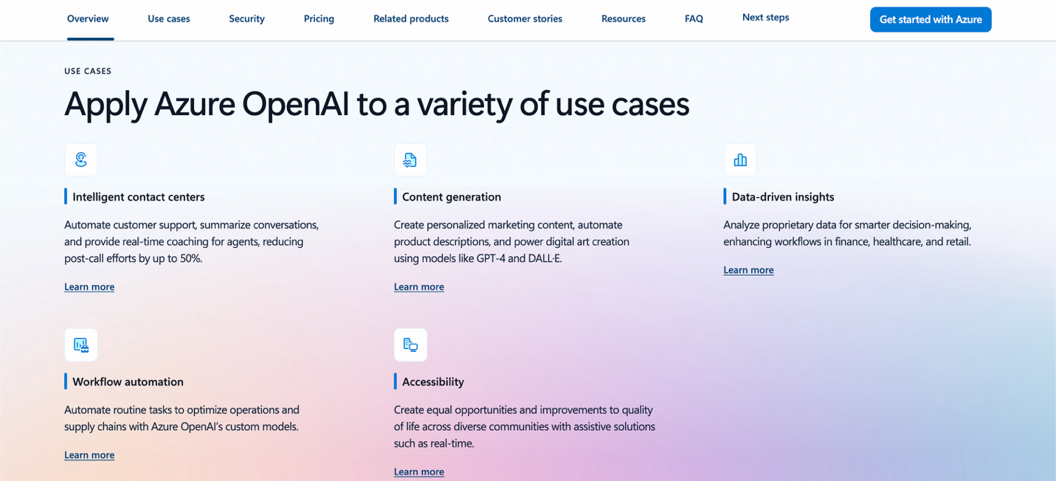

3. Agentic Triage Logic – Prompt Orchestration Requirement

Requirement
The AI must follow structured logic:
- Interpret symptoms
- Assess severity
- Provide category
- Explain reasoning
This requires prompt orchestration at the application layer.

Implementation
The application layer (Flask app) constructs structured prompts that guide the model through deterministic triage reasoning. This simulates agent behavior without requiring complex orchestration platforms.
This approach enables:
- Repeatable AI logic
- Easy customization per clinic
- Controlled AI outputs

4. Triage Logging – Data Storage Requirement

Requirement
Each triage interaction should be logged for:
- Audit purposes
- Historical analysis
- Medical review
- Compliance tracking

Selected Service: Azure Storage Account (Table / Blob Storage)
Azure Storage provides cost-effective, durable storage for structured logs and text records.

Why Azure Storage over Azure SQL or Cosmos DB?
Azure Storage | Azure SQL | Cosmos DB
Low cost for logs | Overkill relational model | Designed for global apps
Simple structured records | Schema management needed | Higher cost
Perfect for audit trails | Not required here | Not required here

Storage accounts are ideal for logging triage records without database complexity.
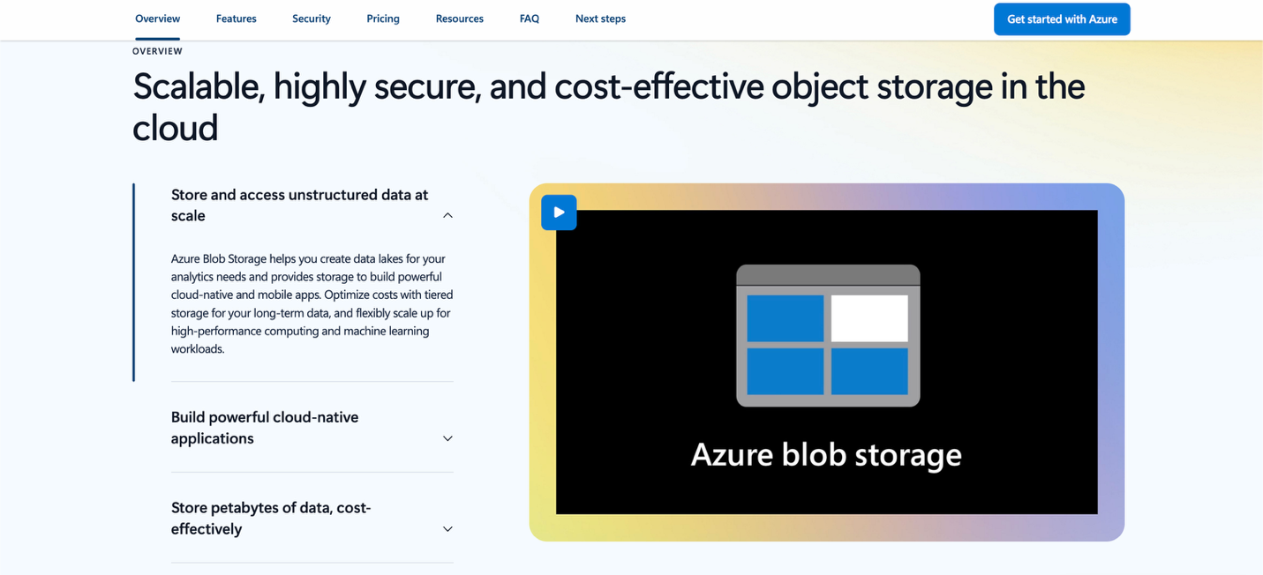

5. Clinic Staff Notification – Workflow Requirement

Requirement
If a patient is classified as “Urgent Care Needed,” clinic staff should be notified automatically.

Selected Service: Azure Logic Apps
Azure Logic Apps enable workflow automation such as sending emails or alerts without writing backend code.

Why Logic Apps over custom email code?
Logic Apps | Custom Code
No code workflow | Development required
Easy integration | Maintenance overhead
Visual workflow design | Less reusable

This makes the system easily adaptable across clinics.
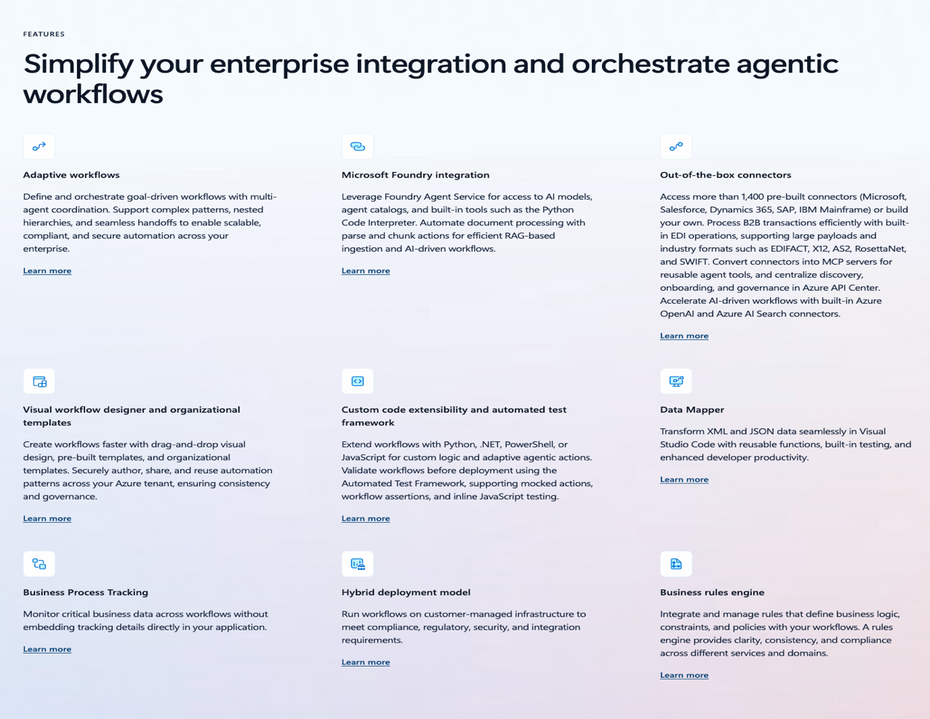

6. Observability – Monitoring Requirement

Requirement
The system must track:
- Request logs
- Errors
- Performance metrics
- Usage trends

Selected Service: Azure Monitor + Application Insights
These services provide automatic telemetry collection from the web app.
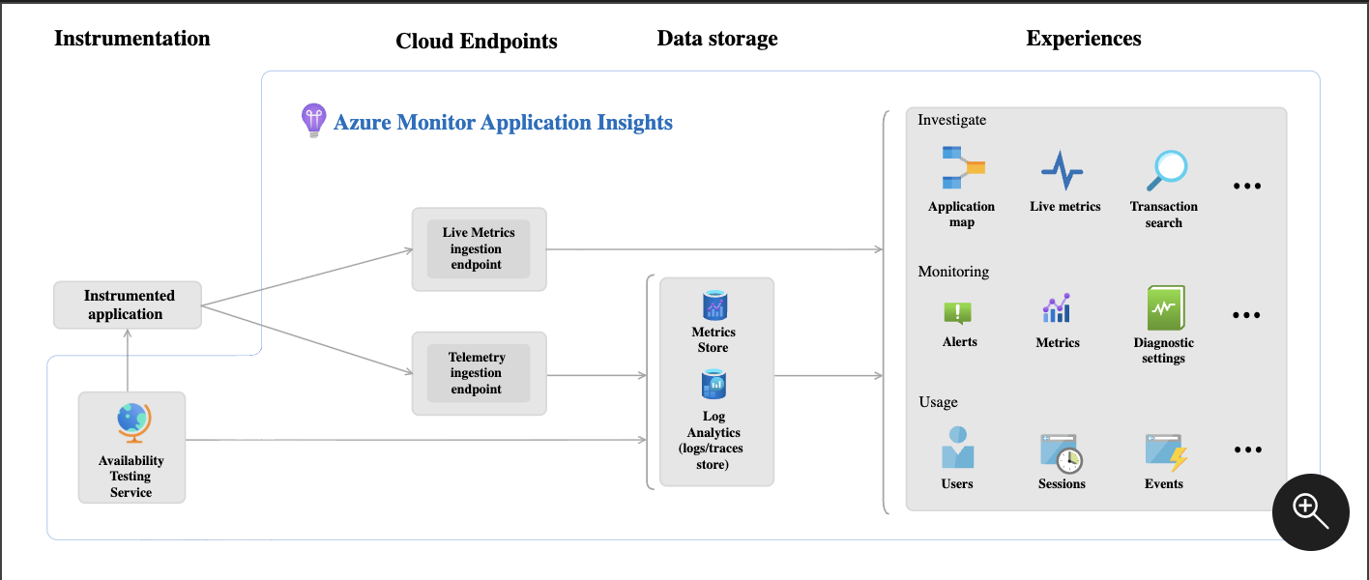

7. Security & Secret Management Requirement

Requirement
API keys and credentials must not be hardcoded into the application.

Selected Service: Azure Key Vault
Azure Key Vault securely stores OpenAI keys and other secrets with role-based access control.
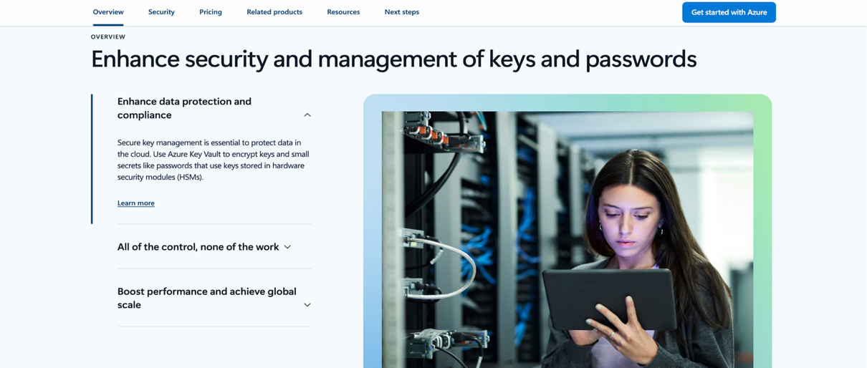

8. Compliance & Governance Considerations
Although this is a POC, the architecture is designed to be HIPAA-aligned by ensuring:
- HTTPS encrypted communication
- Secure key management via Key Vault
- Role-based access control (RBAC)
- Isolated Azure resource group per clinic deployment
- Audit logging via storage
This makes the solution suitable for healthcare environments with minimal modification.

Conclusion
This architecture demonstrates how Azure AI, App Services, and supporting platform services can be combined to create a repeatable AI triage solution for rural healthcare clinics. The design emphasizes:
- Rapid POC to MVP transition
- Agentic AI reasoning
- Secure and compliant deployment
- Low operational overhead
- Reusability across multiple healthcare customers

